List Of Experiments

Sr.  No. | Title | Date of submission | Sign | Remark
1. | Develop an android app which displays “Hello, welcome to Android Lab” message.
2 | Develop an android app which displays a form to get following information from user.
3 | Using Android, Create a login Activity. It asks “username” and “password” from user. If username and password are valid, it displays  Welcome message using new activity.
4 | Develop calculator Android Application.
5 | Study of perform infrared communication.
6 | Study of Bluetooth file transfer in android.

7 | Study of to identify the Bluetooth devices in the wireless range.
8 | Create an application that shows different country name on listview and on selecting it will show flag of that country.

PRACTICAL-1
AIM:- Develop an android app which displays “Hello, welcome to Android Lab” message.
Software used: Java JDK 1.8, Android Studio.

PROGRAM:

Activity_prac1.xml
<?xml version="1.0" encoding="utf-8"?>

<RelativeLayout xmlns:android="http://schemas.android.com/apk/res/android" xmlns:tools="http://schemas.android.com/tools" android:layout_width="match_parent" android:layout_height="match_parent" android:paddingBottom="@dimen/activity_vertical_margin" android:paddingLeft="@dimen/activity_horizontal_margin" android:paddingRight="@dimen/activity_horizontal_margin" android:paddingTop="@dimen/activity_vertical_margin" tools:context="iwt.waytoweb.practicals.Prac5">

<TextView
android:layout_width="wrap_content" android:layout_height="wrap_content" android:text="Hello Welcome to Android Lab!" android:textSize="25dp" android:textStyle="bold" android:textColor="@color/colorAccent" android:layout_marginTop="20dp"/>
</RelativeLayout>

OUTPUT:
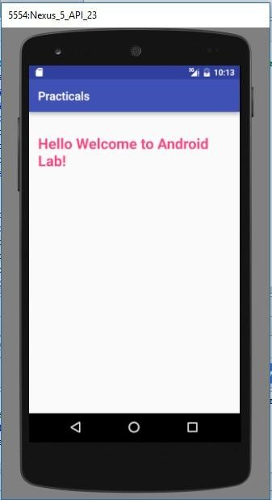

PRACTICAL-2
AIM:- Develop an android app which displays a form to get following information from user.
- Username
- Password
- E-mail Address
- Phone Number
- Country
- State
- Gender
- Interests
- Birth Date
- Birth Time Form should be follow by a button with label “Submit”. When user click the button, a message should be displayed to user describing the information entered.
Utilize Suitable UI controls.
PROGRAM:

Activity_prac2.xml:

<?xml version="1.0" encoding="utf-8"?>
<ScrollView android:layout_height="match_parent" android:layout_width="match_parent" xmlns:android="http://schemas.android.com/apk/res/android" >
<LinearLayout xmlns:android="http://schemas.android.com/apk/res/android" xmlns:tools="http://schemas.android.com/tools" android:layout_width="match_parent" android:layout_height="match_parent" android:layout_marginTop="16dp" android:layout_marginBottom="16dp" android:layout_marginLeft="16dp"
android:layout_marginRight="16dp" tools:context="iwt.waytoweb.practicals.Prac6" android:orientation="vertical" >

<TextView
android:layout_width="wrap_content" android:layout_height="wrap_content" android:text="Registration"android:textColor="@android:color/holo_blue_dark" android:textSize="30dp" android:layout_gravity="center"
android:layout_marginTop="20dp" android:textStyle="bold|italic" android:id="@+id/title"/>

<EditText
android:layout_width="match_parent" android:layout_height="wrap_content" android:hint="User Name" android:inputType="text" android:layout_marginTop="10dp" android:textColorHint="@android:color/black" android:textColor="@android:color/holo_red_light" android:id="@+id/unm" />

<EditText android:textColorHint="@android:color/black"
android:textColor="@android:color/holo_red_light" android:layout_width="match_parent" android:layout_height="wrap_content" android:hint="Password" android:inputType="textPassword" android:id="@+id/pwd" />

<EditText
android:textColorHint="@android:color/black" android:textColor="@android:color/holo_red_light" android:layout_width="match_parent" android:layout_height="wrap_content" android:hint="Email ID" android:inputType="textEmailAddress" android:id="@+id/eid" />

<EditText
android:textColorHint="@android:color/black" android:textColor="@android:color/holo_red_light" android:layout_width="match_parent" android:layout_height="wrap_content" android:hint="Phone Number" android:inputType="phone" android:maxLength="10"
android:id="@+id/pno" />
<AutoCompleteTextView android:layout_width="match_parent" android:layout_height="wrap_content" android:textColorHint="@android:color/black" android:textColor="@android:color/holo_red_light" android:hint="Country" android:inputType="phone"
android:maxLength="10" android:id="@+id/country" />

<Spinner
android:layout_width="match_parent" android:layout_height="wrap_content" android:layout_marginTop="10dp" android:id="@+id/state">

</Spinner>

<RadioGroup
android:layout_width="match_parent" android:layout_height="wrap_content">

<RadioButton
android:layout_width="match_parent" android:layout_height="wrap_content" android:text="Male" android:textColor="@android:color/black" />

<RadioButton
android:layout_width="match_parent" android:layout_height="wrap_content" android:text="Female" android:textColor="@android:color/black" />
</RadioGroup>

<EditText
android:textColorHint="@android:color/black" android:textColor="@android:color/holo_red_light" android:layout_width="match_parent" android:layout_height="wrap_content"
android:hint="Intersets" android:maxLength="10" android:id="@+id/interset"/>

<EditText
android:textColorHint="@android:color/black"
android:textColor="@android:color/holo_red_light" android:layout_width="match_parent" android:layout_height="wrap_content" android:hint="Birthdate"
android:maxLength="10" android:id="@+id/birthdate" />

<EditText
android:textColorHint="@android:color/black" android:textColor="@android:color/holo_red_light" android:layout_width="match_parent" android:layout_height="wrap_content" android:hint="Birth Time" android:maxLength="10" android:id="@+id/birthtime" />

<Button
android:layout_width="250dp" android:layout_height="wrap_content" android:layout_marginTop="40dp" android:layout_marginLeft="60dp" android:text="Register" android:id="@+id/regi" />
</LinearLayout>
</ScrollView>

PRACTICAL-3
AIM-Using Android, Create a login Activity. It asks “username” and “password” from user. If username and password are valid, it displays
Welcome message using new activity.
package iwt.waytoweb.practicals;

import android.support.v7.app.AppCompatActivity; import android.os.Bundle;
import android.view.View;
import android.widget.ArrayAdapter;
import android.widget.AutoCompleteTextView; import android.widget.Button;
import android.widget.EditText; import android.widget.Spinner; import android.widget.Toast;

public class Prac2 extends AppCompatActivity {
EditText username,password,email,phone,interest,birthdate,birthtime; AutoCompleteTextView country;
Spinner states; Button submit;
ArrayAdapter arrayAdapter,arrayAdapter1;String[] Country={"India","Indonesia","Africa","Afghanistan"};
String[] state={"gujarat","goa","maharashtra","rajsthan","aasam","bihar","west bangol"}; @Override
protected void onCreate(Bundle savedInstanceState) { super.onCreate(savedInstanceState);
setContentView(R.layout.activity_prac6); submit= (Button) findViewById(R.id.regi); states= (Spinner) findViewById(R.id.state);
country= (AutoCompleteTextView) findViewById(R.id.country);
arrayAdapter=new ArrayAdapter(Prac6.this,android.R.layout.simple_spinner_item,state); states.setAdapter(arrayAdapter);
country.setThreshold(1); country.setAdapter(arrayAdapter1); submit.setOnClickListener(new View.OnClickListener() {
@Override
public void onClick(View v) {
Toast.makeText(Prac2.this, "Registered successfully... ", Toast.LENGTH_SHORT).show();
}
});

OUTPUT:

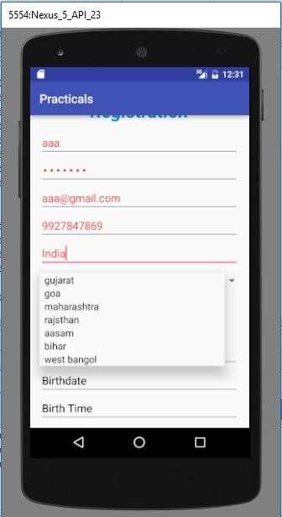
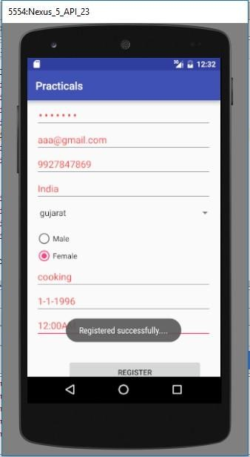

PRACTICAL-4
AIM:-Using Android, Create a login Activity. It asks “username” and “password” from user. If username and password are valid, it displays Welcome message using new activity.
Software used: Java JDK 1.8, Android Studio

PROGRAM:

Activity_prac3.xml

<?xml version="1.0" encoding="utf-8"?>
<RelativeLayout xmlns:android="http://schemas.android.com/apk/res/android" xmlns:tools="http://schemas.android.com/tools" android:layout_width="match_parent" android:layout_height="match_parent" android:paddingBottom="@dimen/activity_vertical_margin" android:paddingLeft="@dimen/activity_horizontal_margin" android:paddingRight="@dimen/activity_horizontal_margin" android:paddingTop="@dimen/activity_vertical_margin" android:layout_centerHorizontal="true" tools:context="iwt.waytoweb.practicals.Prac7">

<TextView
android:layout_width="match_parent" android:layout_height="wrap_content" android:text="Login" android:textColor="#FF212355" android:textStyle="italic" android:textSize="30dp"
android:gravity="center" android:layout_marginTop="20dp" />

<EditText
android:layout_width="match_parent" android:layout_height="wrap_content" android:hint="enter email:" android:id="@+id/email" android:layout_marginTop="60dp" />

<EditText
android:layout_width="match_parent" android:layout_height="wrap_content" android:hint="enter password:"
android:id="@+id/pwd" android:layout_marginTop="120dp" android:inputType="textPassword" />

<Button
android:layout_width="match_parent" android:layout_height="wrap_content" android:text="login" android:id="@+id/login_btn" android:layout_marginTop="180dp" />
</RelativeLayout>

Activity_WelcomePage.xml

<?xml version="1.0" encoding="utf-8"?>
<RelativeLayout xmlns:android="http://schemas.android.com/apk/res/android" xmlns:tools="http://schemas.android.com/tools" android:layout_width="match_parent" android:layout_height="match_parent" android:paddingBottom="@dimen/activity_vertical_margin" android:paddingLeft="@dimen/activity_horizontal_margin" android:paddingRight="@dimen/activity_horizontal_margin" android:paddingTop="@dimen/activity_vertical_margin" tools:context="iwt.waytoweb.practicals.WelcomePage">

<TextView
android:layout_width="wrap_content" android:layout_height="wrap_content" android:text="Welcome to the new page!" android:textSize="25dp" android:textStyle="bold" android:textColor="@color/colorAccent" android:layout_marginTop="20dp"/>
</RelativeLayout>

OUTPUT:

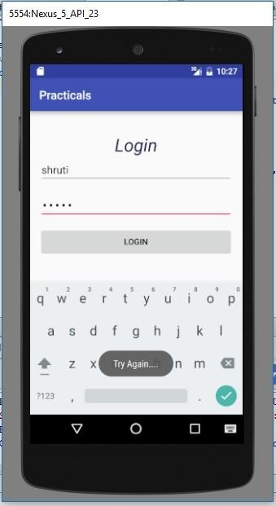
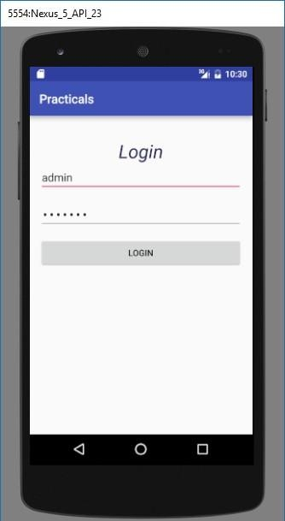

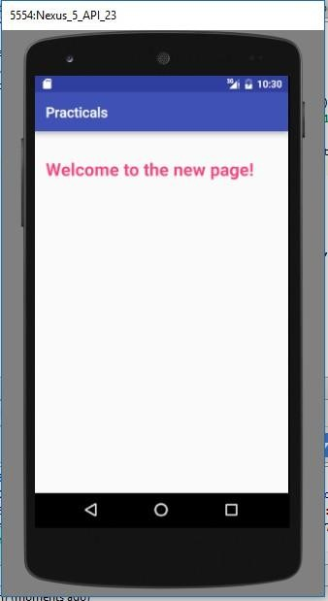

PRACTICAL-5
AIM:-Develop calculator Android Application. Software used: Java JDK 1.8, Android Studio PROGRAM:
import android.support.v7.app.AppCompatActivity; import android.os.Bundle;
import android.view.Menu; import android.view.MenuItem; import android.view.View; import android.widget.Button; import android.widget.EditText;

public class MainActivity extends AppCompatActivity {
Button button0 , button1 , button2 , button3 , button4 , button5 , button6 , button7 , button8 , button9 , buttonAdd , buttonSub , buttonDivision , buttonMul , button10 , buttonC , buttonEqual ;
EditText edt1 ;
float mValueOne , mValueTwo ;
boolean mAddition , mSubtract ,mMultiplication ,mDivision ; @Override
protected void onCreate(Bundle savedInstanceState) { super.onCreate(savedInstanceState); setContentView(R.layout.activity_main);

button0 = (Button) findViewById(R.id.button0); button1 = (Button) findViewById(R.id.button1); button2 = (Button) findViewById(R.id.button2); button3 = (Button) findViewById(R.id.button3); button4 = (Button) findViewById(R.id.button4);
button5 = (Button) findViewById(R.id.button5); button6 = (Button) findViewById(R.id.button6); button7 = (Button) findViewById(R.id.button7); button8 = (Button) findViewById(R.id.button8); button9 = (Button) findViewById(R.id.button9); button10 = (Button) findViewById(R.id.button10); buttonAdd = (Button) findViewById(R.id.buttonadd); buttonSub = (Button) findViewById(R.id.buttonsub); buttonMul = (Button) findViewById(R.id.buttonmul);
buttonDivision = (Button) findViewById(R.id.buttondiv); buttonC = (Button) findViewById(R.id.buttonC); buttonEqual = (Button) findViewById(R.id.buttoneql); edt1 = (EditText) findViewById(R.id.edt1);

button1.setOnClickListener(new View.OnClickListener() { @Override
public void onClick(View v) { edt1.setText(edt1.getText()+"1");
}
});
button2.setOnClickListener(new View.OnClickListener() { @Override
public void onClick(View v) { edt1.setText(edt1.getText()+"2");
}
});
button3.setOnClickListener(new View.OnClickListener() { @Override
public void onClick(View v) { edt1.setText(edt1.getText()+"3");
}
});
button4.setOnClickListener(new View.OnClickListener() { @Override
public void onClick(View v) { edt1.setText(edt1.getText()+"4");
}
});
button5.setOnClickListener(new View.OnClickListener() { @Override
public void onClick(View v) { edt1.setText(edt1.getText()+"5");
}
});
button6.setOnClickListener(new View.OnClickListener() { @Override
public void onClick(View v) { edt1.setText(edt1.getText()+"6");
}
});
button7.setOnClickListener(new View.OnClickListener() { @Override
public void onClick(View v) { edt1.setText(edt1.getText()+"7");
}
});
button8.setOnClickListener(new View.OnClickListener() { @Override
public void onClick(View v) { edt1.setText(edt1.getText()+"8");
}
});
button9.setOnClickListener(new View.OnClickListener() { @Override
public void onClick(View v) { edt1.setText(edt1.getText()+"9");
}
});
button0.setOnClickListener(new View.OnClickListener() { @Override
public void onClick(View v) { edt1.setText(edt1.getText()+"0");
}
});
buttonAdd.setOnClickListener(new View.OnClickListener() { @Override
public void onClick(View v) {

if (edt1 == null){ edt1.setText("");
}else {
mValueOne = Float.parseFloat(edt1.getText() + ""); mAddition = true;
edt1.setText(null);
}
}
});
buttonSub.setOnClickListener(new View.OnClickListener() { @Override
public void onClick(View v) {
mValueOne = Float.parseFloat(edt1.getText() + ""); mSubtract = true ;
edt1.setText(null);
}
});
buttonMul.setOnClickListener(new View.OnClickListener() { @Override
public void onClick(View v) {
mValueOne = Float.parseFloat(edt1.getText() + ""); mMultiplication = true ;
edt1.setText(null);
}
});
buttonDivision.setOnClickListener(new View.OnClickListener() { @Override
public void onClick(View v) {
mValueOne = Float.parseFloat(edt1.getText()+""); mDivision = true ;
edt1.setText(null);
}
});
buttonEqual.setOnClickListener(new View.OnClickListener() { @Override
public void onClick(View v) {
mValueTwo = Float.parseFloat(edt1.getText() + ""); if (mAddition == true){
edt1.setText(mValueOne + mValueTwo +""); mAddition=false;
}
if (mSubtract == true){ edt1.setText(mValueOne - mValueTwo+""); mSubtract=false;
}
if (mMultiplication == true){ edt1.setText(mValueOne * mValueTwo+""); mMultiplication=false;
}
if (mDivision == true){ edt1.setText(mValueOne / mValueTwo+""); mDivision=false;
}
}
});
buttonC.setOnClickListener(new View.OnClickListener() { @Override
public void onClick(View v) { edt1.setText("");
}
});
button10.setOnClickListener(new View.OnClickListener() { @Override
public void onClick(View v) { edt1.setText(edt1.getText()+".");
}
});
}

}

OUTPUT:
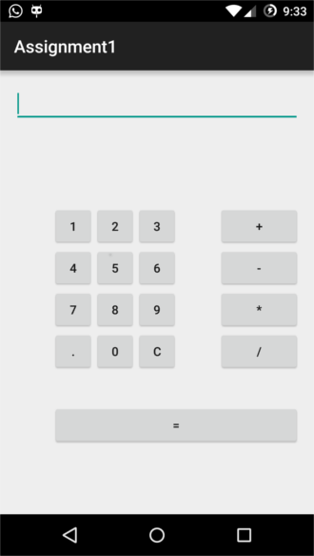

PRACTICAL-6
AIM:-Study of Bluetooth file transfer in android.
Theory:
To develop an Android application making use of data transfers via Bluetooth (BT), one would logically start at the Android Developer's Bluetooth page, where all the required steps are described in details: device discovery, pairing, client/server sockets, RFCOMM channels, etc.
But before jumping into sockets and threads programming just to perform a basic BT operation, let's consider a simpler alternative, based on one of Android's most important features: the ability for a given application to send the user to another one, which, in this case, would be the device's default BT application. Doing so will have the Android OS itself do all the low-level work for us. First things first, a bit of defensive programming:
The above is the first check we need to perform. Done that, let's see how he can start BT from within our own application.
Android will then display all the activities that are able to complete the action we want, in a chooser list. Here's an example:

In the code snippet above, we are letting the Android system know that we intend to send a text file. The system then displays all installed applications capable of handling that action:

We can see that the BT application is among those handlers. We could of course let the user pick that application from the list and be done with it. But if we feel we should be a tad more user- friendly, we need to go further and start the application ourselves, instead of simply displaying it in a midst of other unnecessary options...But how?
One way to do that would be to use Android's Package Manager this way:

The above Package Manager method returns the list we saw earlier of all activities susceptible to handle our file transfer intent, in the form of a list of Resolve Info objects that encapsulate information we need:

//select bluetooth
String packageName = null;
ASCtrEinTg(CcSlEas)sName = null; boolean found = false;
for(ResolveInfo info: appsList){
packageName
=
info.activityInf o.packageNam e;

We now have the necessary information to start BT ourselves:

What we did was to use the package and its corresponding class retrieved earlier. Since we are a curious bunch, we may wonder what the class name for the "com.android.bluetooth" package is. This is what we would get if we were to print it out: com.broadcom.bt.app.opp.OppLauncherActivity. OPP stands for Object Push Profile, and is the Android component allowing to wirelessly share files.
All fine and dandy, but in order for all the above code to be of any use, BT doesn't simply need to be supported by the device, but also enabled by the user. So one of the first things we want to do, is to ask the user to enable BT for the time we deem necessary (here, 300 seconds):

Once we specify that we want to get a result back from our activity with startActivityForResult, the following enabling dialog is presented to the user:
Now whenever the activity finishes, it will return the request codewe have sent (REQUEST_BLU), along with the data and a result code to our main activity through the onActivityResult callback method. We know which request code we have to check against, but how about the result code? Simple: if the user responds "No" to the above permission request (or if an error occurs), the result code will be RESULT_CANCELED. On the other hand, if the user accepts, the BT documentation specifies that the result code will be equal to the duration that the device is discoverable (i.e. DISCOVER_DURATION, i.e. 300).
So the way to process the BT dialog above would be:

Putting all our processing flow in order, here's what we are basically doing:

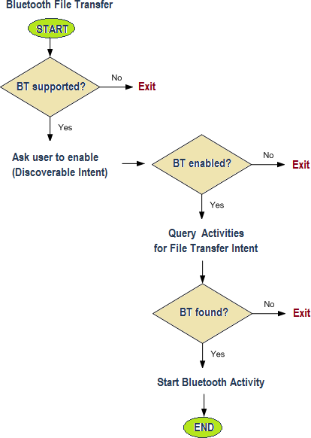

Are we done yet? Almost. Last but not least, we need to ask for the BT permissions in the Android manifest:

We're ready to deploy now. To test all this, we need to use at least two Android devices, one being the file sender (where our application is installed) and the other any receiving device supporting BT. Here are the screen shots. For the sender:

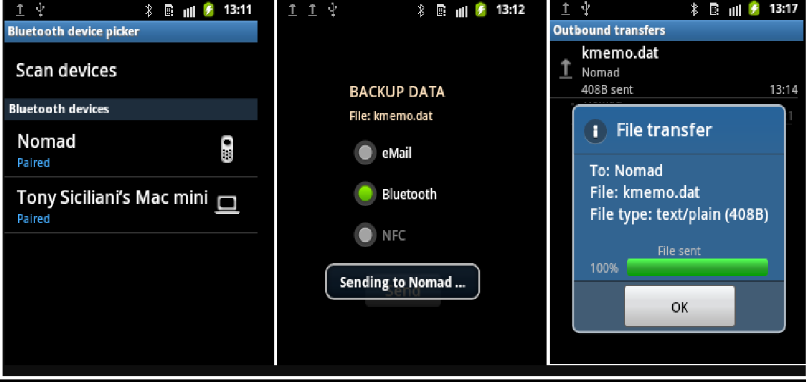

PRACTICAL-7
AIM:-Study of to identify the Bluetooth devices in the wireless range.
Software used: Python 3.4 and PyBluez package(version 0.22)

Theory:-
Bluetooth is a wireless technology standard for exchanging data over short distances (using short-wavelength UHF radio waves in the ISM band from 2.4 to 2.485 GHz) from fixed and mobile devices, and building personal area networks (PANs). Invented by telecom vendor Ericsson in 1994, it was originally conceived as a wireless alternative to RS-232 data cables.

Bluetooth is managed by the Bluetooth Special Interest Group (SIG), which has more than 30,000 member companies in the areas of telecommunication, computing, networking, and consumer electronics. The IEEE standardized Bluetooth as IEEE 802.15.1, but no longer maintains the standard. The Bluetooth SIG oversees development of the specification, manages the qualification program, and protects the trademarks. A manufacturer must meet Bluetooth SIG standards to market it as a Bluetooth device. A network of patents apply to the technology, which are licensed to individual qualifying devices.

Implementation of Bluetooth: Bluetooth is a packet-based protocol with a master-slave structure. One master may communicate with up to seven slaves in a piconet. All devices share the master's clock. Packet exchange is based on the basic clock, defined by the master, which ticks at 312.5 µs intervals. Two clock ticks make up a slot of 625 µs, and two slots make up a slot pair of 1250 µs. In the simple case of single-slot packets the master transmits in even slots and receives in odd slots. The slave, conversely, receives in even slots and transmits in odd slots. Packets may be 1, 3 or 5 slots long, but in all cases the master's transmission begins in even slots and the slave's in odd slots.

Connection establishment and communication: A master BR/EDR Bluetooth device can communicate with a maximum of seven devices in a piconet (an ad-hoc computer network using Bluetooth technology), though not all devices reach this maximum. The devices can switch roles, by agreement, and the slave can become the master (for example, a headset initiating a connection to a phone necessarily begins as master—as initiator of the connection—but may subsequently operate as slave).

At any given time, data can be transferred between the master and one other device (except for the little-used broadcast mode[citation needed]). The master chooses which slave device to address; typically, it switches rapidly from one device to another in a round-robin fashion. Since it is the master that chooses which slave to address, whereas a slave is (in theory) supposed to listen in each receive slot, being a master is a lighter burden than being a slave. Being a master of seven slaves is possible; being a slave of more than one master is possible. The specification is vague as to required behavior in scatternets.

PROGRAM:

import bluetooth

nearby_devices = bluetooth.discover_devices(lookup_names=True) print("found %d devices" % len(nearby_devices))
for addr, name in nearby_devices: print(" %s - %s" % (addr, name))

OUTPUT:
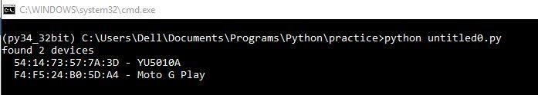

PRACTICAL-8
AIM:- Create an application that shows different country name on listview and on selecting it will show flag of that country.
activity_main.xml:-
<RelativeLayout xmlns:android="http://schemas.android.com/apk/res/android"
xmlns:tools="http://schemas.android.com/tools" android:layout_width="match_parent" android:layout_height="match_parent"
android:paddingLeft="@dimen/activity_horizontal_margin" android:paddingRight="@dimen/activity_horizontal_margin" android:paddingTop="@dimen/activity_vertical_margin" android:paddingBottom="@dimen/activity_vertical_margin" tools:context=".MainActivity">
<!-- Here we are defining ListView in our XML file-->

<ListView android:layout_width="match_parent" android:layout_height="wrap_content" android:id="@+id/list"/>
</RelativeLayout>

MainActivity.java

package com.coderefer.simplelistview; import android.content.Intent;
import android.os.Bundle;

import android.support.v7.app.AppCompatActivity; import android.view.Menu;
import android.view.MenuItem; import android.view.View;
import android.widget.AdapterView; import android.widget.ArrayAdapter; import android.widget.ListView; import android.widget.Toast;
public class MainActivity extends AppCompatActivity {
//Defining android ListView ListView mListView;
//Elements that will be displayed in android ListView

String[] Countries = new String[]{"India", "Australia", "Newzealand", "Indonesia", "China", "Russia", "Japan", "South Korea"};
//Ids of flag Images that are placed in res> drawable folder. They return the int value int[] FlagId = new int[]{R.drawable.flag_india, R.drawable.flag_australia,
R.drawable.flag_newzealand,R.drawable.flag_indonesia, R.drawable.flag_china, R.drawable.flag_russia,R.drawable.flag_japan, R.drawable.flag_southkorea};
@Override
protected void onCreate(Bundle savedInstanceState) { super.onCreate(savedInstanceState); setContentView(R.layout.activity_main); mListView = (ListView) findViewById(R.id.list);
//Declaring Array adapter
ArrayAdapter<String> countryAdapter = new ArrayAdapter<String>(this,android.R.layout.simple_list_item_1, Countries);
//Setting the android ListView's adapter to the newly created adapter mListView.setAdapter(countryAdapter);
mListView.setOnItemClickListener(new AdapterView.OnItemClickListener() { @Override
public void onItemClick(AdapterView<?> parent, View view, int position, long id) {

//The position where the list item is clicked is obtained from the

//the parameter position of the android listview int itemPosition = position;
//Get the String value of the item where the user clicked

String itemValue = (String) mListView.getItemAtPosition(position

//In order to start displaying new activity we need an intent

Intent intent = new Intent(getApplicationContext(),CountryActivity.class);

//Putting the Id of image as an extra in intent intent.putExtra("flag",FlagId[position]);
//Here we will pass the previously created intent as parameter startActivity(intent);
}

});

}

@Override

public boolean onCreateOptionsMenu(Menu menu) {

// Inflate the menu; this adds items to the action bar if it is present. getMenuInflater().inflate(R.menu.menu_main, menu);
return true;

}

@Override

public boolean onOptionsItemSelected(MenuItem item) {
// Handle action bar item clicks here. The action bar will

// automatically handle clicks on the Home/Up button, so long

// as you specify a parent activity in AndroidManifest.xml. int id = item.getItemId();
//noinspection SimplifiableIfStatement if (id == R.id.action_settings) {
return true;

}

return super.onOptionsItemSelected(item);

}

}

activity_country.xml

<RelativeLayout xmlns:android="http://schemas.android.com/apk/res/android"
xmlns:tools="http://schemas.android.com/tools" android:layout_width="match_parent" android:layout_height="match_parent"
android:paddingLeft="@dimen/activity_horizontal_margin" android:paddingRight="@dimen/activity_horizontal_margin" android:paddingTop="@dimen/activity_vertical_margin" android:paddingBottom="@dimen/activity_vertical_margin" tools:context="com.coderefer.simplelistview.CountryActivity">
<ImageView
android:layout_width="wrap_content" android:layout_height="wrap_content" android:id="@+id/ivCountryFlag" android:layout_centerVertical="true"
android:layout_centerHorizontal="true" />

</RelativeLayout>

CountryActivity.java

package com.coderefer.simplelistview; import android.content.Intent;
import android.support.v7.app.ActionBarActivity; import android.os.Bundle;
import android.view.Menu; import android.view.MenuItem;
import android.widget.ImageView;
public class CountryActivity extends ActionBarActivity { @Override
protected void onCreate(Bundle savedInstanceState) { super.onCreate(savedInstanceState); setContentView(R.layout.activity_country);
ImageView imageView = (ImageView) findViewById(R.id.ivCountryFlag); Intent i = getIntent();
int FlagId = i.getIntExtra("flag",0); imageView.setImageResource(FlagId);
}

@Override

public boolean onCreateOptionsMenu(Menu menu) {

// Inflate the menu; this adds items to the action bar if it is present. getMenuInflater().inflate(R.menu.menu_country, menu);
return true;
}

@Override

public boolean onOptionsItemSelected(MenuItem item) {

// Handle action bar item clicks here. The action bar will

// automatically handle clicks on the Home/Up button, so long

// as you specify a parent activity in AndroidManifest.xml. int id = item.getItemId();
//noinspection SimplifiableIfStatement if (id == R.id.action_settings) {
return true;

}

return super.onOptionsItemSelected(item);

}

}

OUTPUT:-

